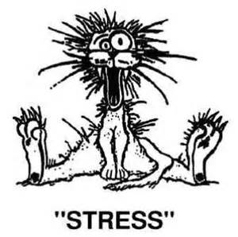

People are disturbed not by a thing, but by their perception of a thing
-Epictetus-
What do you think is meant by Epictetus’ quote?

What is stress?

Define the term stressor

Identify 2 examples of good stress and 2 examples of bad stress.
Good Stress | Bad Stress

What are some signs and symptoms of stress?

What is the difference between acute stress and chronic stress?

What is the 3 stage response to stress? Draw the diagram below.

Describe what is meant by the “Flight or Fight” response.

What is the difference between the parasympathetic and the sympathetic nervous system?

What are some of the long term effects of stress?

How does our mind respond to stress?

“Stress is insidious.” What does this mean and why is it a concern?

Where are some common places stress can hide?

